Perineal massage:
This should only be performed during the last four weeks of pregnancy & with the prior approval of your healthcare provider.

Many women find that becoming familiar with the sensation of the perineum stretching before the excitement surrounding delivery can be helpful for the pushing stage.

DO NOT perform perineal massage if there is an active infection (e.g. herpes). It is ALWAYS a good idea to talk to your healthcare provider before initiating any new interventions.

Clip your fingernails & wash your hands first.
Assemble plenty of pillows so you can comfortably position yourself in a semi-reclining position. Some women find applying a warm compress to the area first may help relax the perineum. If semi-reclining is not comfortable, try standing with one foot on a stool.

Rub some lubricant on the outside of the perineum. Gently hook the tip of one or both thumbs shallowly into the vagina. Gently stretch the thumbs out and downwards towards either side of the anus, until you feel a sensation of comfortable stretch/ tingling.

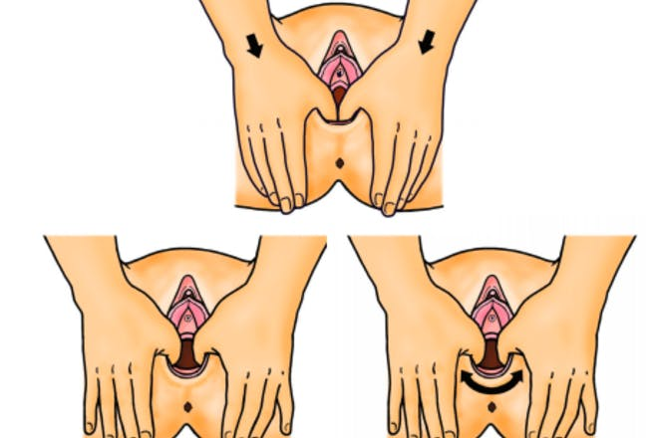

Hold for approximately 60 seconds (the average length of a contraction), then rest for a minute or two to allow the circulation to move through the perineal area. Focus especially on the ‘out breath’ with a gentle bearing down to allow the perineum to comfortably and gently stretch with your thumbs – you are training your perineum to relax with the out breath, which will be important during delivery.

This should not be a painful stretch!

Repeat the stretch two or three times more, keeping it comfortable and relaxed.

If you have a history of prolapse, place a wedge under your buttocks to lift pelvis to work with gravity.

